Go to AWS policy generator - <https://awspolicygen.s3.amazonaws.com/policygen.html> - to create the IAM policy

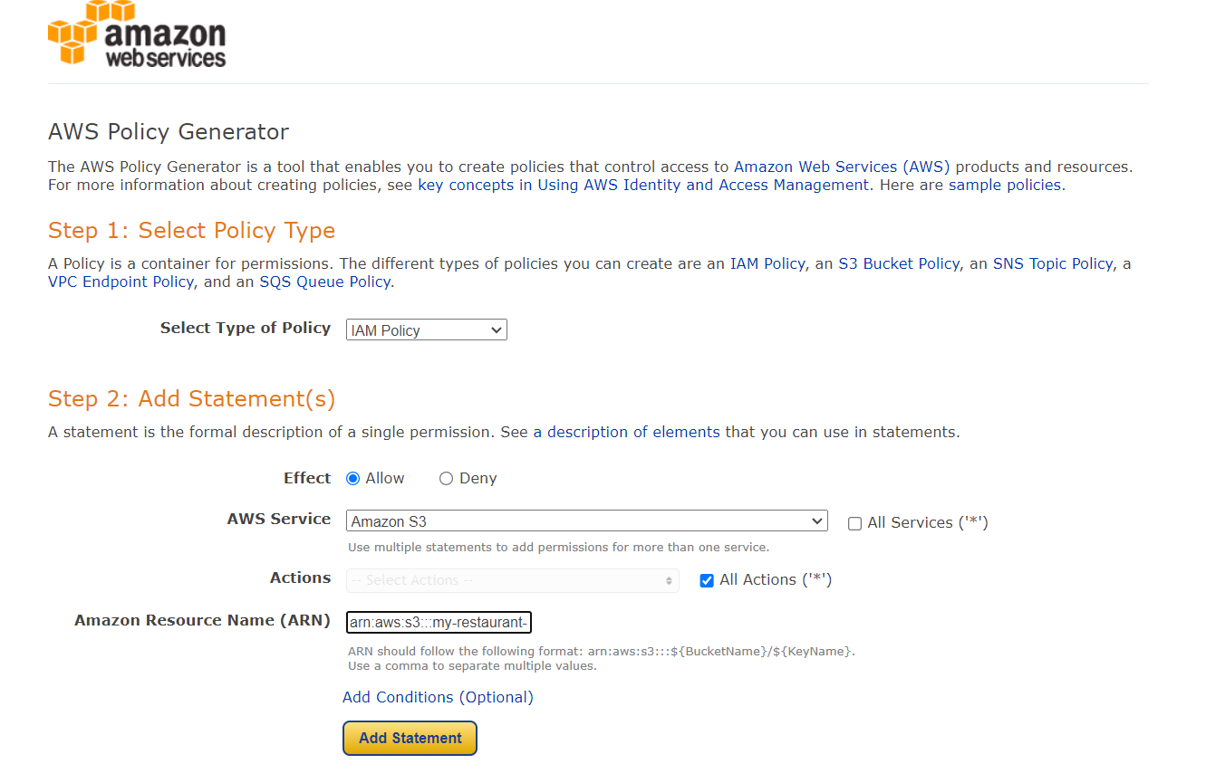

Note that the ARN refers to both bucket and the bucket contents

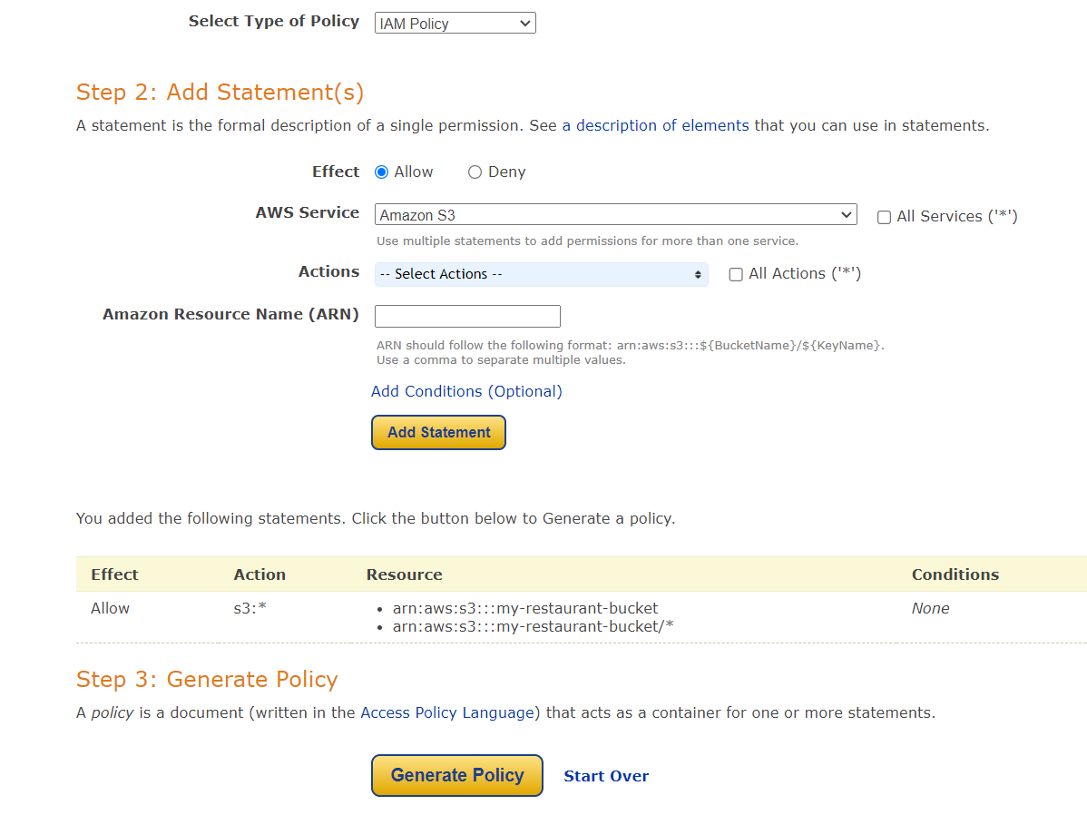

Generate the policy here and copy the contents

Go to IAM -> Create policy -> JSON

Create policy and put in the contents copied earlier

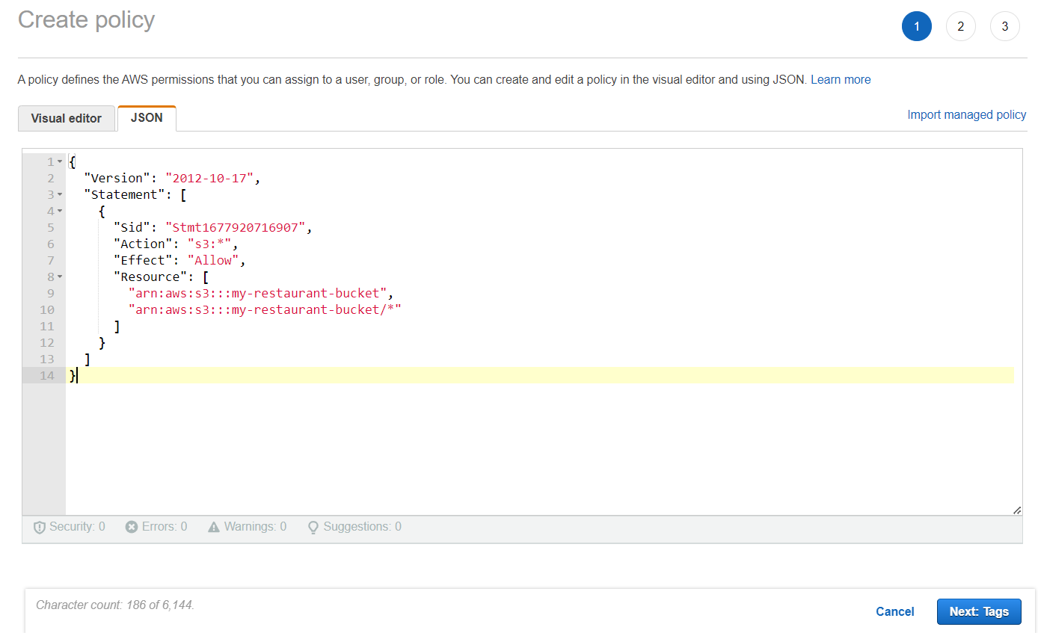

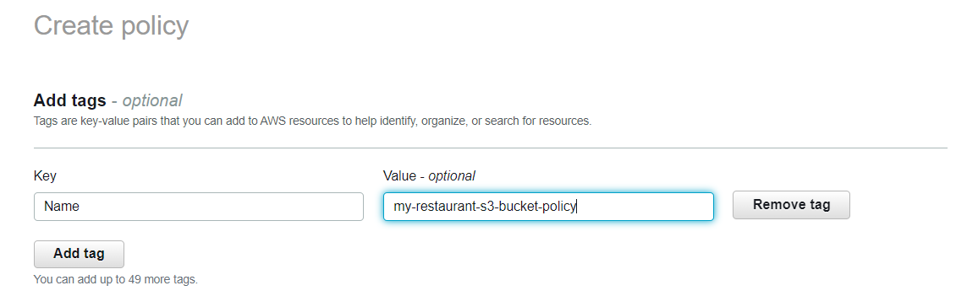

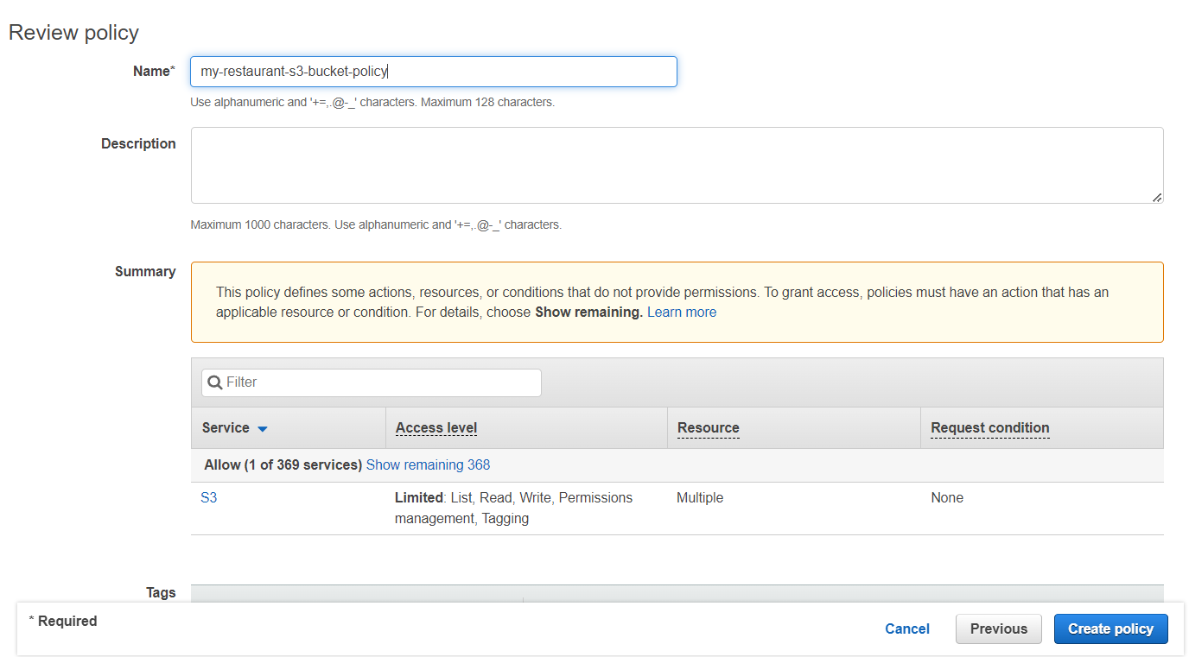

Now create a role for EC2 instance using this policy, because the EC2 instances launched in the public subnet of my-restaurant-vpc must be able to access the S3 bucket to pull the source code for the web page.

